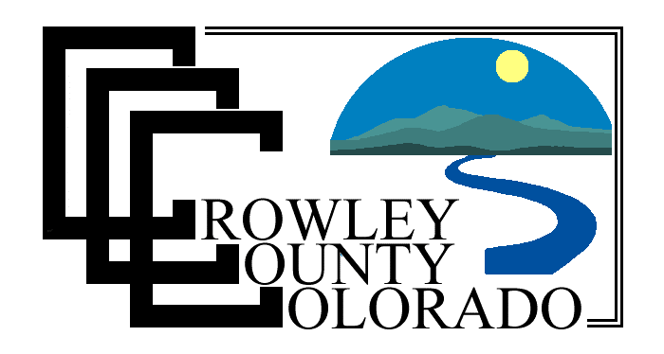

APRIL 28, 2025, 8:30 A.M.

BOARD OF COUNTY COMMISSIONERS

AGENDA

- CONVENE
- NEW BUSINESS
  - APPROVE DHS DISBURSEMENTS, APRIL 25, 2025
  - APPROVE CERTIFICATE OF COST ALLOCATION PLAN
- OTHER BUSINESS OR DISCUSSION
- MONTHLY PRISON MEETING (9:30 A.M.)

COMMISSIONER WORK SESSIONS OCCUR MONDAY – FRIDAY FROM 8:00 A.M. TO 4:00 P.M. THE PUBLIC IS WELCOME TO ATTEND.

This agenda is provided for informational purposes only. Action may be taken on any or all the items. All times are approximate. If any given item is finished earlier than anticipated, the Commissioners may move on to the next item. The only exceptions are public hearings on items which have had published notices of a specific hearing time; those items will not begin until the specific time or after.

